

InstallShield®

AdminStudio

Canis Setup

Specification

Owner(s) Jigar Desai

Last Updated 6/23/2003 10:58:00 PM

File Name 0000.doc

© 1999 InstallShield Software Corporation. All rights reserved.
THIS IS PRELIMINARY DOCUMENTATION. The information contained in this document represents the current view of InstallShield Software Corporation on the issues discussed as of the date of publication. Because InstallShield must respond to changing market conditions, it should not be interpreted to be a commitment on the part of InstallShield, and InstallShield cannot guarantee the accuracy of any information presented after the date of publication.
This BETA document is for informational purposes only. INSTALLSHIELD MAKES NO WARRANTIES, EXPRESS OR IMPLIED, IN THIS DOCUMENT.
Other product or company names mentioned herein may be the trademarks of their respective owners.
InstallShield Software Corporation • 900 National Parkway • Schaumburg, Illinois 60173-5108

Table of Contents

^{1.0 Abstract} 3
^{2.0 Requirements} 3
3.0 Features Reserved for Future Versions 4
^{4.0 Limitations} 4
^{5.0 Issues} 4
^{6.0 Revision History} 4

^{1.0 Abstract}
This documents outlines the requirements for the AdminStudio Canis (AdminStudio 5.0 Value Pack 1) setup. This release will be a full build and not as a patch.

^{2.0 Requirements}
- Perform an upgrade from previous versions of InstallShield AdminStudio except AdminStudio 3.5 RTM (with Developer 7.04).
- Have a new product code and package code.
- Validate the serial number in the UISequence.
- Launch the registration wizard at the end of the install if Developer 8 is installed.
- Setup will consists of the following:
    - All features will be installed on the local machine.
    - Tuner will be installed in <ProgramFiles>\InstallShield\5.0\Tuner
    - ConflictSolver will be installed in <ProgramFiles>\InstallShield\5.0\ConflictSolver
    - Repackager will be installed in <ProgramFiles>\InstallShield\5.0\Repackager
    - IPWI will be installed in <ProgramFiles>\InstallShield\5.0\Developer.
    - QualityMonitor will be installed in <ProgramFiles>\InstallShield\5.0\Repackager
- Shortcut will look like this:

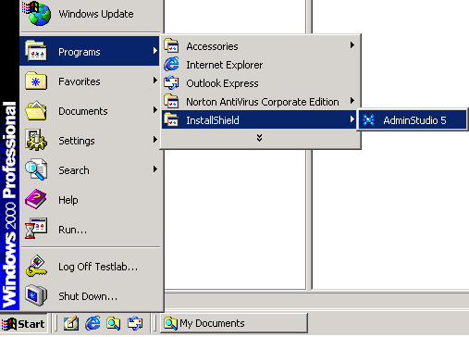
So there will no tools shortcut.
- Developer will be launched using EXE custom action.
- There will be a Type 226 exe custom action called InstallDeveloperFull to launch the Developer 8.02 Setup with Canis 5.0.
Action: InstallDeveloper8
Type: 226
Source: DEVSOURCE (Developer source folder)
Target: "[DEVSOURCE]Setup.exe" /v"/qr ARPSYSTEMCOMPONENT=1 INSTALLDIR=\"[INSTALLDIR]Developer\" PIDKEY=\"[ProductID]\" COMPANYNAME=\"[COMPANYNAME]\" USERNAME=\"[USERNAME]\" ISSCHEDULEREBOOT=1 ISLAUNCHEDFROMAS=1 LANGSELECTED=\"[DEVLANG]\""

This custom action will be placed under InstallExecuteSeuqence after InstallFinalize action (Sequence no. 6651) with Condition - Not Installed.

- Canis Setup will launch the Developer Setup only if Developer is not installed and AdminStudio is not installed.
- Uninstalling AdminStudio will uninstall Developer (if installed with AdminStudio). There is a custom action called UninstallDeveloperFull for this.

Action: UninstallDeveloperFull
Type: 226
Source: SystemFolder
Target: "[SystemFolder]msiexec.exe" /x {50ECAF32-EBA9-4DCB-9E0D-65ACE3D8FBF6} /qb

^{3.0 Upgrade}

This section describes the Upgrade scenarios for AdminStudio Canis.

Scenario 1: Install AS 2.0. Install Canis.
Expected Result: Major Upgrade

Scenario 2: Install AS 3.0 Professional Edition. Then install Canis.
Expected Result: Major Upgrade

Scenario 3: Install AS 3.0 Standard Edition. Then install Canis.
Expected Result: Major Upgrade

Scenario 4: Install AS 3.01 Professional Edition. Then install Canis.
Expected Result: Major Upgrade

Scenario 5: Install AS 3.01 Standard Edition. Then install Canis.
Expected Result: Major Upgrade

Scenario 6: Install AS 3.01 Professional. Install Value Pack1. Now install Canis.
Expected Result: Major Upgrade

Scenario 7: Install AS 3.5 RTM (with Developer 7.04). Install Canis.
Expected Result: Launch Condition to let users uninstall it manually.

Scenario 8: Install AS 3.5. Install VP1. Install Canis.
Expected Result: Major Upgrade

Scenario 9: Install AS 3.5. Install VP1. Install VP2. Install Canis.
Expected Result: Major Upgrade

Scenario 10: Install AS 5.0. Install Canis.
Expected Result: Major Upgrade

Scenario 11: Install AS 5.0. Install SP1. Install Canis.
Expected Result: Major Upgrade

^{4.0 Limitations}

^{5.0 Issues}

^{6.0 Revision History}

Date | Author | Change Reference
06/01/2003 | Jigar Desai | Initial Draft

